# Abstract:

**MECE 5397 Scientific Computing**

**Spring 2019**

**Final Project**

**Numerical Solution for the**

**Diffusion Equation – [B01-1]**



Jonah R. Smith, PSID: 1569818

Professors: A. Amritkar, and A. Prosperetti

Date of Submissions: 05/05/2019

# Problem Statement

The purpose of this project was to solve a simple 2D diffusion equation with no source terms using two solution methods, and be able to determine grid convergence and convergence to steady state using these two methods. The mathematical statement of the problem is as follows:

$$\frac{∂^{2}u}{∂x^{2}}+\frac{∂^{2}u}{∂y^{2}}=\frac{∂u}{∂t} (1)$$

Subject to the following constraints and boundary conditions:

$$a_{x}<x<b_{x}, a_{y}<y<b_{y}$$

$$u\left(x,b_{y}\right)=f_{b}\left(x\right), u\left(x,a_{y}\right)=g_{b}\left(x\right)$$

$$\frac{∂u}{∂x}{\left.​\right|}_{x=b_{x}}=0, u\left(a_{x},y\right)=g_{b}\left(a_{x}\right)+\frac{y-a_{y}}{b_{y}-a_{y}}\left[f_{b}\left(a_{x}\right)-g_{b}(a_{x})\right]$$

That is, there are three Dirichlet boundary conditions on the surface, and one Neumann boundary condition at $x=b_{x}$. For this problem, the following values were given:

$$a_{x}=a_{y}=0, b_{x}=b_{y}=2π$$

$$f_{b}\left(x\right)={\left(b_{x}-x\right)}^{2}\cos\left(\frac{πx}{b_{x}}\right), g_{b}\left(x\right)=x{\left(b_{x}-x\right)}^{2}$$

For reference, the following figure shows the domain of the problem and approximately what the Dirichlet boundary conditions look like on an x-y plot, and the Neumann boundary is left empty. This plot was made using 64 nodes in both the x and y directions.

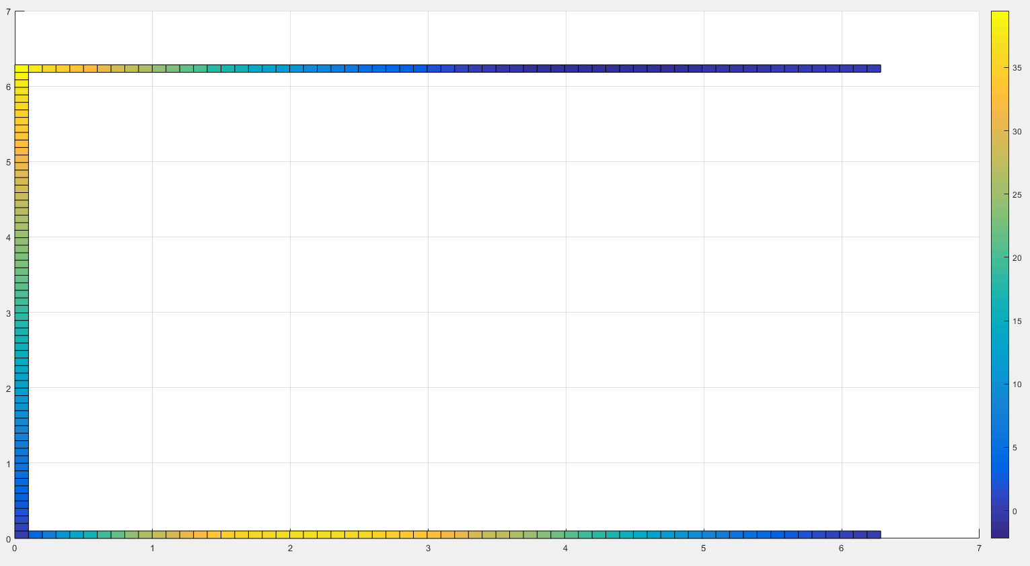

Figure 1: Map of Dirichlet Boundary Conditions

# ADI and Explicit Discretizations of the Diffusion Equation

## ADI Method

For this project, two different solution methods were used to solve the equation: ADI, and the explicit method. The Alternating Direction Implicit (ADI) scheme is an implicit solution method which is also able to take advantage of the Thomas Algorithm when solving multi-dimensional diffusion equations. The ADI scheme works by breaking down each timestep into two “half-timesteps” (for 2D equations). The solution routine takes these half-timesteps alternating between the x and y directions, assuming constant values in the direction about which the timestep is not currently being taken. Given Equation 1, this results in the following discretization:

$$\frac{u_{i,j}^{n+1/2}-u_{i,j}^{n}}{Δt/2}=∇_{x}^{2}u_{i,j}^{n+1/2}+∇_{y}^{2}u_{i,j}^{n} (2)$$

$$\frac{u_{i,j}^{n+1}-u_{i,j}^{n+1/2}}{Δt/2}=∇_{x}^{2}u_{i,j}^{n+1/2}+∇_{y}^{2}u_{i,j}^{n+1} (3)$$

Where:

$$∇_{x}^{2}u_{i,j}^{n}=\frac{u_{i-1,j}^{n}-2u_{i,j}^{n}+u_{i+1,j}^{n}}{Δx^{2}} (4)$$

$$∇_{y}^{2}u_{i,j}^{n}=\frac{u_{i,j-1}^{n}-2u_{i,j}^{n}+u_{i,j+1}^{n}}{Δy^{2}} (5)$$

Equations 4 and 5 give the discretization used to approximate derivatives along the x and y directions respectively. For any given $x=x_{i}$, $y=y_{j}$, this equation uses a stencil as shown below in Figure 2. By using the ADI method, $u_{i-1,j}$, $u_{i,j}$, and $u_{i+1,j}$ are solved simultaneously by assuming values are known for $u_{i,j-1}$ and $u_{i,j+1}$ from the previous half-timestep’s solution. Then, $u_{i,j-1}$, $u_{i,j}$, and $u_{i,j+1}$ are solved simultaneously by using the values for $u_{i-1,j}$ and $u_{i+1,j}$ that were just found.

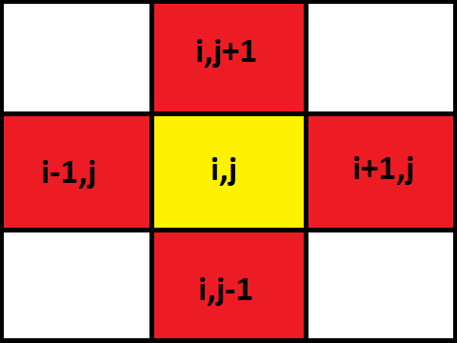

Figure 2: Stencil Used in Discretization

## Explicit Method

The explicit method is much simpler than the ADI routine, solving each $u_{i,j}$ for the new timestep independently of the solutions for other nodes at the new timestep. Instead, the solution for each node at the next time interval is a function of the values for u from the previous timestep using the same stencil as before. This discretization takes the following form of Equation 6.

$$\frac{u_{i,j}^{n+1}-u_{i,j}^{n}}{Δt}=∇_{x}^{2}u_{i,j}^{n}+∇_{y}^{2}u_{i,j}^{n} (6)$$

The explicit method has the advantage of quick solution times, as there is no need to use the Taylor algorithm to solve any system of equations, as there is a direct explicit solution for each node. However, the explicit method is much more unstable and prone to error than the ADI method, requiring a significantly smaller timestep to be taken in order to achieve the same level of accuracy, making this method often take longer to run than the ADI method to achieve the same level of accuracy.

# Description of Numerical Methods

## Setting up the Problem

The code created for both the ADI and Explicit methods are extremely similar. The only difference between the two is what happens within the loop that solves for each $u_{i,j}$. The code is setup such that the script Main.m is used to call either ADI.m or Explicit.m, functions for the two solution routines. The functions return a vector x, which is a vector containing the locations in x of each node, a vector y, which is a vector containing the locations in y of each node, an array u, which contains the solution to the equation, and the time taken to run the solution routine. A plot of the results can be made using surf(x,y,u’). Both ADI.m and Explicit.m must be provided the following inputs when not running from a previous run’s savefile:

1. (**ax**) ~ This variable is $a_{x}$ from the setup of the problem, and should be assigned a value of 0.
2. (**bx**) ~ This variable is $b_{x}$ from the setup of the problem, and should be assigned a value of 2π.
3. (**ay**) ~ This variable is $a_{y}$ from the setup of the problem, and should be assigned a value of 0.
4. (**by**) ~ This variable is $b_{y}$ from the setup of the problem, and should be assigned a value of 2π.
5. (**nodefacx**) ~ This variable defines the level of nodalization in the x direction. The number of interior nodes in the x direction is given by (ceil(2^(nodefacx))-2.
6. (**nodefacy**) ~ This variable defines the level of nodalization in the y direction. The number of interior nodes in the y direction is given by (ceil(2^(nodefacy))-2.
7. (**DTIMEI**) ~ DTIMEI is a control constant that will be referenced many times throughout this report, and is simply the name given to $Δt$, the size of each timestep. For the ADI routine, each half-timestep is DTIMEI/2. Additionally, the code uses the variable **TIMEN** to keep track of how many timesteps have been taken, such that TIMEN = (number of timesteps taken)*DTIMEI.
8. (**maxrelerror**) ~ The max relative error for some $u_{i,j}$ between two consecutive timesteps for the script to consider itself to have not yet reached steady state before terminating. An appropriate value for this is discussed in the Results section of this report.
9. (**savefilename**) ~ The filename to regularly save the Workspace of the function, such that this savefile can be loaded in and the solution routine can pick back up from where it left off. For values of DTIMEI less than 1, saves occur every 50/DTIMEI iterations. For values of DTIMIE greater than 1, saves occur every 50 iterations. The code only checks for convergence to steady state each time that this save routine occurs. In order to run the script using a savefile, create a structure by loading in the savefile to a variable, and then passing this structure as the only argument to either ADI.m or Explicit.m, as shown in Figure 3 below.

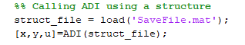

Figure 3: Calling the Solution Routine Using a Savefile

For both functions, the script begins by either loading in a savefile from a previous run of the function, or by setting up an array for x, y, and u, and creating a simple guess for u by using a linear approximation between the $y=a_{x}$ and $y=b_{x}$ boundary conditions. The following snippet of code in Figure 4 shows how this initial value for u is derived, and how the Dirichlet boundary conditions are setup.

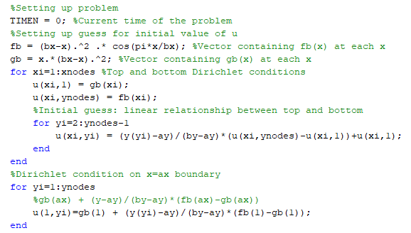

Figure 4: Setting up Dirichlet Boundary Conditions, and Creating an Initial Value for u

The variables **xnodes** and **ynodes** are constant values that give the number of nodes (including 1 node for each boundary) in either the x or y direction. The vector **x** is an **xnodes** by 1 array, where $x\left(n\right)=\left(n-1\right)Δx$, such that $x\left(1\right)=0$, and $x(xnodes)$ = $b_{x}$. Vectors **gb** and **fb** correspond to $g_{b}(x)$ and $f_{b}(x)$ found in the description of the problem, where $gb\left(n\right)=g_{b}\left(\left(n-1\right)Δx\right)$, and likewise for $fb(n)$. This means that the internal nodes within u are given by

u(2:xnodes-1,2:ynodes-1), and that the values for u at the Neumann boundary are given by u(xnodes,:).

If loading in a savefile rather than setting up the problem, the code verifies that only one variable was passed into the function, and that this variable is a structure. The function then unpacks each of the variables inside of the structure into the Workspace by using the simple script shown below in Figure 5.

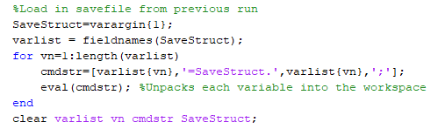

Figure 5: Loop to Unpack Savefile into the Workspace

The cell array **varargin** is a built-in method of MATLAB that allows for a variable number of parameters to be passed into a function, each variable being stored inside a cell of **varargin**. The loop pulls out the save structure from **varargin{1}**, and proceeds to make a new variable in the Workspace for each field in the save structure.

## Solution Routine – ADI

The discretization given for the ADI routine in Equations 2/3 works well for interior nodes that are not adjacent to the boundary conditions, but require some extra work when dealing with nodes adjacent to the boundaries. Because of the implicit solution type using the Thomas Algorithm, it’s important to understand how to move information from the boundaries that would be in the matrix $A$ given the equation $A\vec{u}=\vec{f}$ into the vector f on the RHS of the equation. The Thomas Algorithm follows from constructing the following matrix:

$$\left[\begin{matrix}a_{1} & c_{1} & 0 \\ b_{2} & a_{2} & c_{2} \\ 0 & b_{3} & a_{3}\end{matrix}\right]\left[\begin{matrix}u_{1} \\ u_{2} \\ u_{3}\end{matrix}\right]=\left[\begin{matrix}f_{1} \\ f_{2} \\ f_{3}\end{matrix}\right]$$

Interior nodes not adjacent to a boundary would follow the form of $u_{2}$ in the above matrix. In our problem, $u_{1}$ would either be adjacent to the Dirichlet condition at $x=a_{x}$ or $y=a_{y}$, and $u_{3}$ would be adjacent to the Dirichlet condition at $y=b_{y}$ or the Neumann condition at $x=b_{x}$ (depending on if the half-timestep is taken in x or y).

To fit our discretization into the form of this matrix, our equations 2 and 3 can be expanded to the following forms:

$$\left[\frac{-1}{Δx^{2}}\right]u_{i-1,j}^{n+1/2}+\left[\frac{2}{Δt}+\frac{2}{Δx^{2}}\right]u_{i,j}^{n+1/2}+\left[\frac{-1}{Δx^{2}}\right]u_{i+1,j}^{n+1/2}=\left[\frac{2}{Δt}-\frac{2}{Δy^{2}}\right]u_{i,j}^{n}+\left[\frac{1}{Δy^{2}}\right]\left(u_{i,j-1}^{n}+u_{i,j+1}^{n}\right)$$

$$\left[\frac{-1}{Δy^{2}}\right]u_{i,j-1}^{n+1}+\left[\frac{2}{Δt}+\frac{2}{Δy^{2}}\right]u_{i,j}^{n+1}+\left[\frac{-1}{Δy^{2}}\right]u_{i,j+1}^{n+1}=\left[\frac{2}{Δt}-\frac{2}{Δx^{2}}\right]u_{i,j}^{n}+\left[\frac{1}{Δx^{2}}\right]\left(u_{i-1,j}^{n}+u_{i+1,j}^{n}\right)$$

For half-timesteps along x, the subscript $i$ changes each iteration, and the following values are taken:

$$a=\left[\frac{2}{Δt}+\frac{2}{Δx^{2}}\right]$$

$$b=c=\left[\frac{-1}{Δx^{2}}\right]$$

$${f_{x}}_{i,j}=\left[\frac{2}{Δt}-\frac{2}{Δy^{2}}\right]u_{i,j}^{n}+\left[\frac{1}{Δy^{2}}\right]\left(u_{i,j-1}^{n}+u_{i,j+1}^{n}\right)$$

For half-timesteps along y, the subscript $j$ changes each iteration, and the following values are taken:

$$a=\left[\frac{2}{Δt}+\frac{2}{Δy^{2}}\right]$$

$$b=c=\left[\frac{-1}{Δy^{2}}\right]$$

$${f_{y}}_{i,j}=\left[\frac{2}{Δt}-\frac{2}{Δx^{2}}\right]u_{i,j}^{n}+\left[\frac{1}{Δx^{2}}\right]\left(u_{i-1,j}^{n}+u_{i+1,j}^{n}\right)$$

Although it would simplify the code to force $Δx=Δy$, the code allows for a different level of nodalization to be taken in either the x or y direction for purposes of code verification, and for the chance that one dimension may require a much lower level of refinement than the other.

In order to modify values for $f$ to work with nodes adjacent to a boundary, we need to do the following exercise:

$$\left[\frac{-1}{Δx^{2}}\right]u_{0,j}^{n+1/2}+\left[\frac{2}{Δt}+\frac{2}{Δx^{2}}\right]u_{1,j}^{n+1/2}+\left[\frac{-1}{Δx^{2}}\right]u_{2,j}^{n+1/2}=\left[\frac{2}{Δt}-\frac{2}{Δy^{2}}\right]u_{i,j}^{n}+\left[\frac{1}{Δy^{2}}\right]\left(u_{i,j-1}^{n}+u_{i,j+1}^{n}\right)$$

Here, $u_{0,j}^{n+1/2}=u_{0,j}$, a constant value per the Dirichlet condition. Simply move this to the RHS side of the equation to get a new value for $f_{1,j}$.

$${f_{x}}_{1,j}=\left[\frac{1}{Δx^{2}}\right]u_{0,j}+\left\{\left[\frac{2}{Δt}-\frac{2}{Δy^{2}}\right]u_{1,j}^{n}+\left[\frac{1}{Δy^{2}}\right]\left(u_{1,j-1}^{n}+u_{1,j+1}^{n}\right)\right\}$$

Similarly, for the Dirichlet conditions at $y=a_{x}$ and $y=b_{x}$ (assuming N interior nodes):

$${f_{y}}_{i,1}=\left[\frac{1}{Δy^{2}}\right]u_{i,0}+\left\{\left[\frac{2}{Δt}-\frac{2}{Δx^{2}}\right]u_{i,1}^{n}+\left[\frac{1}{Δx^{2}}\right]\left(u_{i-1,1}^{n}+u_{i+1,1}^{n}\right)\right\}$$

$${f_{y}}_{1,N}=\left[\frac{1}{Δy^{2}}\right]u_{i,N+1}+\left\{\left[\frac{2}{Δt}-\frac{2}{Δx^{2}}\right]u_{i,N}^{n}+\left[\frac{1}{Δx^{2}}\right]\left(u_{i-1,N}^{n}+u_{i+1,N}^{n}\right)\right\}$$

Finally, we need to deal with ${f_{x}}_{N+1,j}$, due to the Neumann boundary condition at $x=b_{x}$. To do this, we can assume a “ghost node” at $x=b_{x}+Δx$, and get the following relationships:

$$Neumann Boundary Condition: \frac{∂u}{∂x}{\left.​\right|}_{x=b_{x}}=0$$

$$\frac{∂u_{i,j}}{∂x}{\left.​\right|}_{i=N+1}≈\frac{u_{N+2,j}-u_{N,j}}{2Δx}=0$$

$$u_{N+2,j}=u_{N,j}$$

$${f_{x}}_{N+1,j}=\left[\frac{1}{Δx^{2}}\right]u_{N+1,j}+\left\{\left[\frac{2}{Δt}-\frac{2}{Δy^{2}}\right]u_{1,j}^{n}+\left[\frac{1}{Δy^{2}}\right]\left(u_{1,j-1}^{n}+u_{1,j+1}^{n}\right)\right\}$$

$$b_{N+1,j}=2b=\left[\frac{-2}{Δx^{2}}\right]$$

Notice that this Neumann boundary condition is the only place where b is not the same, so rather than store b as a vector, it is efficient from a memory perspective to keep b as a constant, and simply perform a unique operation outside of the main for-loop to solve for $u_{N+1,j}$.

**Pseudo code for the Thomas Algorithm, using the ADI method:**

% Differentiating along the x direction first

for j=1:N

% Define a, b, c, constants and f a vector per above for this j at each i

alpha = zeros(N+1); g=zeros(N+1);

alpha(1) = a; g(1) = f(1);

for i=2:N

alpha(i) = a - b*c/alpha(i-1);

g(i) = f(i) - b*g(i-1)/alpha(i-1); %Make sure f(1) accounts for the Dirichlet condition

end

%Now to apply the Neumann conditions to solve for u(N+1,j)

alpha(N+1) = a – 2*b*c/alpha(N); %Notice the use of 2*b rather than b

g(N+1) = f(N+1);

u(N+1,j) = g(N+1)/alpha(N+1);

for k=N:-1:1

u(k,j) = (g(k)-c*u(k+1,j))/alpha(k);

end

end

% Differentiating along the y direction now

for i=1:N

% Define a, b, c, constants and f a vector per above for this i at each j

alpha = zeros(N); g=zeros(N);

alpha(1) = a; g(1) = f(1);

for j=2:N

alpha(j) = a - b*c/alpha(j-1);

g(j) = f(j) - b*g(j-1)/alpha(j-1); %Make sure f(1) and f(N) account for the Dirichlet condition

end

u(i,N) = g(N)/alpha(N);

for k=N-1:-1:1

u(i,k) = (g(k)-c*u(i, k+1))/alpha(k);

end

end

TIMEN = TIMEN + DTIMEI;

**Actual code snippets from ADI.m**

These snippets of code show how the ADI routine looks in the actual MATLAB code. Keep in mind that x(1)=ax, and x(xnodes)=bx, and y(1)=ay and y(ynodes)=by.

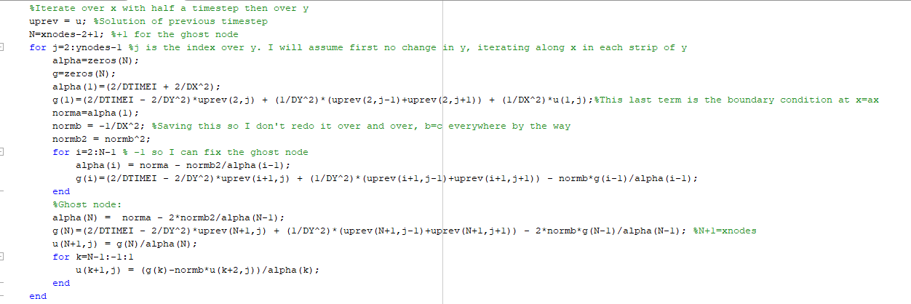

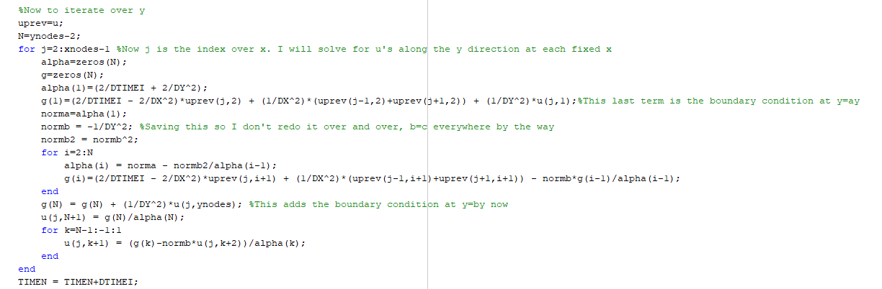

Figure 6: ADI Solution Routine Code

## Solution Routine – Explicit

The solution routine for the explicit method is much simpler. Using Equation 6, we can create a formula for each $u_{i,j}$ as follows.

$$u_{i,j}^{n+1}=u_{i,j}^{n}+Δt\left(\frac{u_{i-1,j}^{n}-2u_{i,j}^{n}+u_{i+1,j}^{n}}{Δx^{2}}+\frac{u_{i,j-1}^{n}-2u_{i,j}^{n}+u_{i,j+1}^{n}}{Δy^{2}}\right) (8)$$

Given how $u$ was defined in the code to have the values at each boundary stored within $u$ rather than only containing interior nodes, no additional code needed to be used to apply the Dirichlet boundary conditions outside of the main for-loop. To apply the Neumann boundary condition, a “ghost node” at $x=b_{x}+Δx$ was assumed in order to create the following equations (recall that $x\left(xnodes\right)=b_{x}$).

$$Neumann Boundary Condition: \frac{∂u}{∂x}{\left.​\right|}_{x=b_{x}}=0$$

$$\frac{∂u_{i,j}}{∂x}{\left.​\right|}_{i=xnodes}≈\frac{u_{xnodes+1,j}-u_{xnodes-1,j}}{2Δx}=0$$

$$u_{xnodes+1,j}=u_{xnodes-1,j}$$

Plugging this in to Equation 8, this gives the solution for $u$ along the Neumann boundary condition:

$$u_{xnodes,j}^{n+1}=u_{xnodes,j}^{n}+Δt\left(2\frac{u_{xnodes-1,j}^{n}-u_{xnodes,j}^{n}}{Δx^{2}}+\frac{u_{xnodes,j-1}^{n}-2u_{xnodes,j+1}^{n}+u_{xnodes,j+1}^{n}}{Δy^{2}}\right)$$

Translating this into code, the solution routine takes the following form in Figure 7. This code also shows how maximum relative error is used to check for convergence.

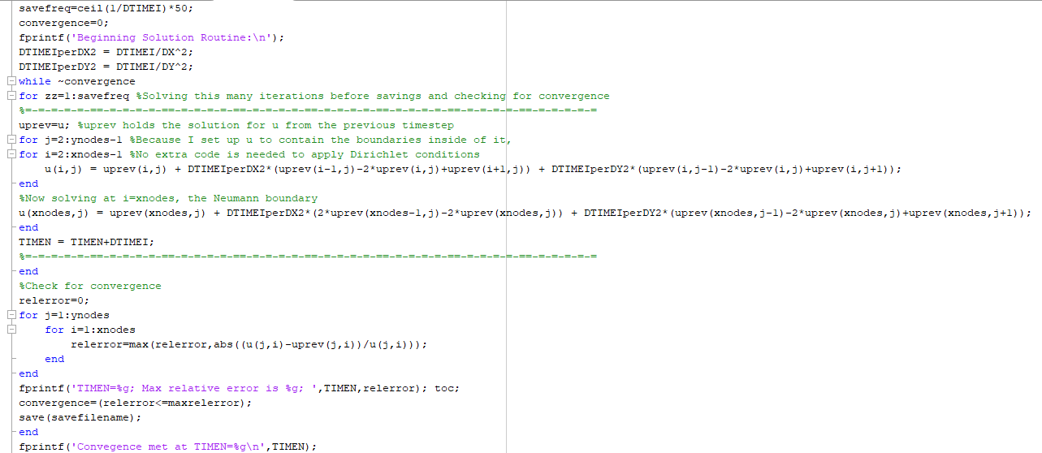

Figure 7: Explicit Solution Routine Code, and Code for Maximum Relative Error

# Machine Specifications

The machine used to run this script was a Lenovo Ideapad 700, and has the following specifications:

* Intel i7-6700HQ CPU @ 2.60GHz
  + 4 CPU Cores
  + L1 Cache – 256 KB
  + L2 Cache – 1 MB
  + L3 Cache – 6 MB
* 16 GB DDR4 RAM
* NVIDIA GeForce GTX 950M Graphics Card (Dedicated 4GB VRAM)
  + Additionally, 8 GB of Shared GPU memory using integrated graphics: Intel HD Graphics 530
* Software: MATLAB R2016a

# Results and Verification

## Tabular and Graphical Results

The program was able to successfully solve the Diffusion equation using both the ADI and Explicit methods. The code reached steady state somewhere between TIMEN=50 and TIMEN=100. It was found that when the script was run to TIMEN = 100, the maximum relative error between two consecutive timesteps became close to the level of error expected from floating-point precision error. The following table compares some key runtime parameters for different grid sizes and timesteps using the two routines. In this table, max relative error is a measurement of the maximum relative change between the final two timesteps taken by the script.

Table 1: Explicit Routine Runtime and Steady State Convergence for Varying Grid Size

|  |  |  |  |
| --- | --- | --- | --- |
| Explicit Routine | | | |
| **DTIMEI** | **Number of Nodes** | **Max Rel. Error Achieved at TIMEN = 100** | **Runtime (s)** |
| 0.01 | 8x8 | 1.9787e-16 | 0.02 |
| 0.0025 | 16x16 | 2.0067e-16 | 0.17 |
| 6.25e-4 | 32x32 | 2.0764e-16 | 2.6 |
| 1.5625e-4 | 64x64 | 2.3676e-16 | 43.2 |
| 3.9063-5 | 128x128 | 2.2189e-16 | 705 |

Table 2: ADI Routine Runtime and Steady State Convergence for Varying Grid Size

|  |  |  |  |
| --- | --- | --- | --- |
| ADI Routine | | | |
| **DTIMEI** | **Number of Nodes** | **Max Rel. Error Achieved at TIMEN = 100** | **Runtime (s)** |
| 0.1 | 8x8 | 4.6726e-16 | 0.015 |
| 0.025 | 16x16 | 4.09328e-16 | 0.045 |
| 6.25e-3 | 32x32 | 2.95624e-16 | 0.55 |
| 1.5625e-3 | 64x64 | 3.55144e-15 | 8.5 |
| 3.9063-4 | 128x128 | 2.82976e-15 | 144.3 |



Figure 8: Explicit (left) and ADI (right) Solutions for 8x8 Nodes at TIMEN = 100



Figure 9: Explicit (left) and ADI (right) Solutions for 16x16 Nodes at TIMEN = 100



Figure 10: Explicit (left) and ADI (right) Solutions for 32x32 Nodes at TIMEN = 100

Figure 11: Explicit (left) and ADI (right) Solutions for 64x64 Nodes at TIMEN = 100

Figure 12: Explicit (left) and ADI (right) Solutions for 128x128 Nodes at TIMEN = 100

From visual inspection, we can see that the two scripts produced approximately the same solutions as one another. Notice from Table 1 and Table 2, a ten times larger DTIMEI was used for the ADI routine than was used for the Explicit routine. This was chosen from testing, which showed that using this large of a DTIMEI for the Explicit routine would result in unbounded behavior, whereas decreasing DTIMEI for the ADI routine beyond this showed negligible change in the solution for u. Comparing Table 1 and Table 2, we see that using this 10 times larger DTIMEI in the ADI routine resulted in the solution running approximately 5 times faster.

## Determining Grid Convergence

We saw from our plots that even when comparing a grid of 8x8 nodes to a grid of 128x128 nodes, the same trend in results was shown, for both the ADI and Explicit solution methods. It is clear from these figures that increasing the grid size gives more detail to the solution based on the more diverse gradient of colors that can be seen, but nevertheless, the same overall trend can be seen using any of Figures 8-12. These graphs help show that there does not appear to be any individual points within the interior of the solutions which vary from each other based on grid size. Since it is difficult to truly compare results at individual points between solutions of different grid sizes, as the positions of each node do not line up, Table 3 and Table 4 below shows some overall statistical results of the solutions looking at just the interior nodes (not the boundary nodes) to have an easy to understand metric of the effects of grid size on the solution.

Table 3: Explicit Routine Results for Varying Grid Size

|  |  |  |  |
| --- | --- | --- | --- |
| **Grid Size** | **Max of Interior Nodes** | **Min of Interior Nodes** | **Mean of Interior Nodes** |
| 8x8 | 24.9209 | 2.83809 | 13.2608 |
| 16x16 | 31.6113 | 0.608702 | 13.7204 |
| 32x32 | 35.544 | -0.712928 | 13.9424 |
| 64x64 | 37.5389 | -1.43913 | 14.052 |
| 128x128 | 38.523 | -1.81481 | 14.1064 |

Table 4: ADI Routine Results for Varying Grid Size

|  |  |  |  |
| --- | --- | --- | --- |
| **Grid Size** | **Max of Interior Nodes** | **Min of Interior Nodes** | **Mean of Interior Nodes** |
| 8x8 | 24.9209 | 2.83809 | 13.2608 |
| 16x16 | 31.6113 | 0.608702 | 13.7204 |
| 32x32 | 35.544 | -0.712928 | 13.9424 |
| 64x64 | 37.5389 | -1.43913 | 14.052 |
| 128x128 | 38.523 | -1.81481 | 14.1064 |

Surprisingly, the Explicit and ADI routines had consistent results against each other with a high-level of accuracy for any given grid size, but this is using a ten times smaller DTIMEI for these Explicit results. Declaring that grid convergence has or has not been achieved is a hard term to define in many senses. The third column in Tables 1 and 2 from before showed that steady state had been achieved to almost a machine-precision level of accuracy in all of these runs (max relative error being on the order of 1e-16 or 1e-15 between two consecutive timesteps). The trends in Tables 3 and 4 explain that much more detail can be achieved by increasing the grid size, but even without increasing the grid size, the same general trends are shown in Figures 8-12. A general trend from Tables 3 and 4 is that the delta between any two values from doubling the grid size is halved with each consecutive increase in grid size. Between these two tables and the previous figures, a reasonable conclusion is that an appropriate grid size to describe the solution of this equation would range between 64x64 to 128x128, even though a coarser mesh is still capable of giving a strong understanding of the solution.

## Effects of Using Large DTIMEI

As previously mentioned, the Explicit method has unbounded behavior when using too large of a timestep. Increasing the number of nodes used requires decreasing the timestep, or else values for u shoot off to infinity very quickly. For instance, using a DTIMEI of 0.01 works perfectly fine for the ADI method with a 64x64 grid size, but causes a full array of NaN’s for the Explicit method. However, if the grid size is reduced to 32x32, then the Explicit method is able to calculate the appropriate solution. From testing, a general rule of thumb is that doubling the number of discretizatons in each direction for either solution method requires quartering the size of the timestep (four times as many nodes requires approximately one-fourth the size of the timestep). For example, the Explicit method is able to produce real results with a grid size of 32x32 using a DTIMIE $≈$ 0.01, and with a grid size of 64x64 using DTIMEI $≈$ 0.00225. The ADI method is able to produce real results with a grid size of 32x32 with a DTIMIE $≈$ 0.055, and with a grid size of 64x64 using DTIMEI $≈$ 0.0125. From both of these cases, we see that the maximum allowable time step which results in the solution being bounded is about 5.5 times larger using the ADI method than it is using the Explicit method.

## Additional Verification

As a simple verification test, a third script was produced called Explicit_Verification.m to solve a simple Diffusion equation with a known solution. This script had four Dirichlet boundary conditions, featuring extremely few edits to the code to preserve the function of the original script. The setup for this problem is:

$$u\left(x,b_{y}\right)=\frac{x-a_{x}}{b_{x}-a_{x}}=u\left(x,a_{y}\right)$$

$$u\left(a_{x},y\right)=0, u\left(a_{x},y\right)=1$$

We would expect a flat plane with no curvature with a constant increasing slope to be produced. The code successfully created this plane, as shown in the following figures:



Figure 13: Verification Run

Additionally, the effects of changing $a_{x}$ to be a value of π rather than 0 was run to show that the code can adjust to changes in the input parameters, and retain the correct solution to the equation.



Figure 14: Verification Run Using $a_{x}=π$

This verification script did once again require that DTIMEI be reduced enough such that no unbounded behavior occurs, but the script had no problem reaching steady state (once again within a TIMEN of 100).